Camp Millhouse Packing List
Item | Suggested Amount | # packed
T-shirts | 6-8 tops
Shorts | 6-8 pair
Jeans | 1-2 pair
Underwear | 8-10 pair
Socks | 8-10 pair
Bras | 3 or more
Wash Cloths | 5
Towels for bathing | 3
Towel for the pool | 1
Pajamas (light weight) | 1-3 pair
Soap (liquid or bar) | 1
Shampoo | 1
Conditioner | 1
Toothbrush/Toothpaste | 1
Bug spray | 1
Sunscreen | 1
Eating aids (if needed) | 1set
Feeding pump, bags and formula | Proper amount needed
Sweatshirt/Jacket | 1
Swimsuit | 1
Twin sheets-flat & fitted-see below* | 1
Pillow w/pillowcase | 1 or more
Light-weight blanket | 1
Pull-Ups/Briefs/Attends | Plenty to last the week
Sanitary pads | Plenty to last the week
Laundry bag | 1
Camp Store Money | $5.00 bring to check-in day
Please do not bring electronic devices (including cameras) unless medically necessary or used as a part of a behavior support plan or bedtime routine.
***Camp Millhouse is not responsible for any lost items***
PACKING TIPS
Please be sure to mark all belongings with your camper’s first initial & last name in permanent marker.
New packing request: When packing your camper’s clothes, could you please pack them as individual outfits by rolling everything for one day together (shirt, shorts, underwear, & socks) and rubberbanding/taping it, or putting each days outfit in a 1 or 2 gallon Ziploc-type bag. By doing so, it helps us help your camper build independence as we can ask them to “grab an outfit” or “which outfit do you want” from the five bagged or rolled outfits. Extra clothes can just be in their bag as usual.
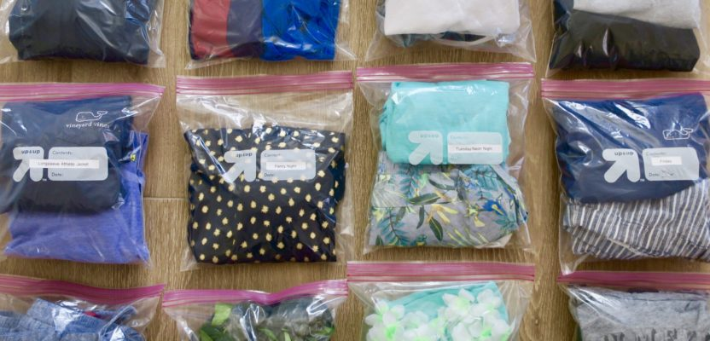
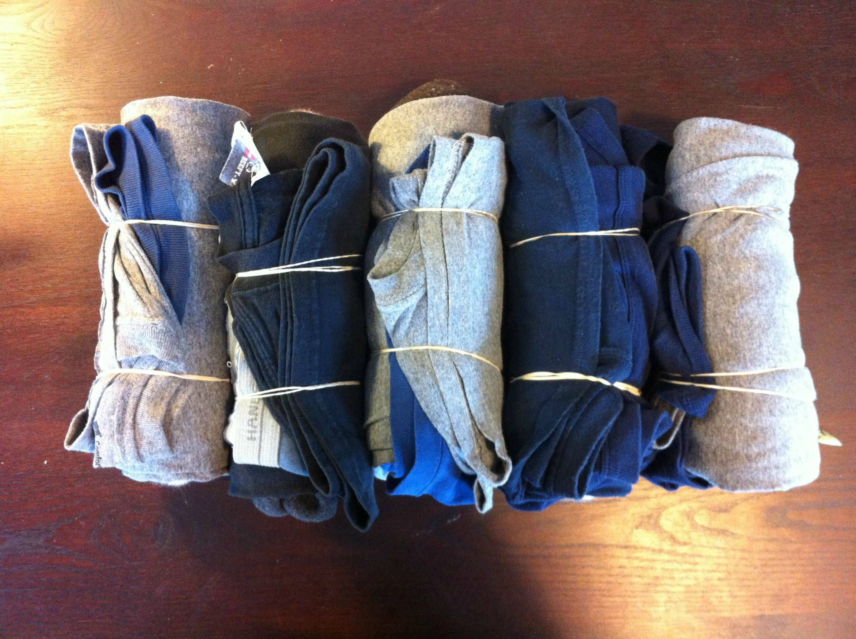

Note: Laundry is available for emergencies only. Please be sure your camper packs enough clothes to last the week.

*Please do NOT send a sleeping bag of any kind. If our staff have to wash your camper’s bedding due to an accident, we cannot wash sleeping bags. Please send bed sheets, a light blanket and a pillow with a pillowcase. Thank you for understanding.

